
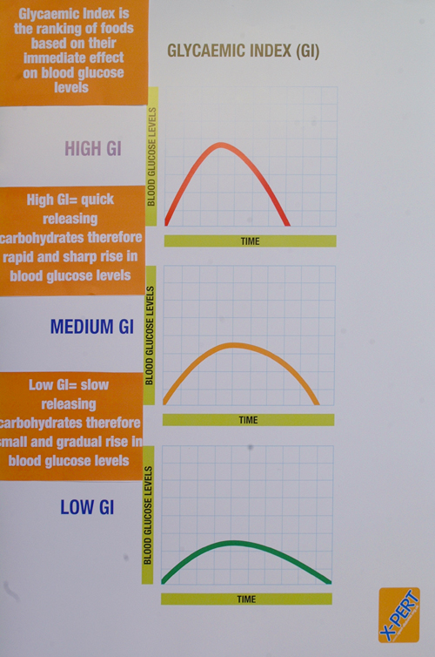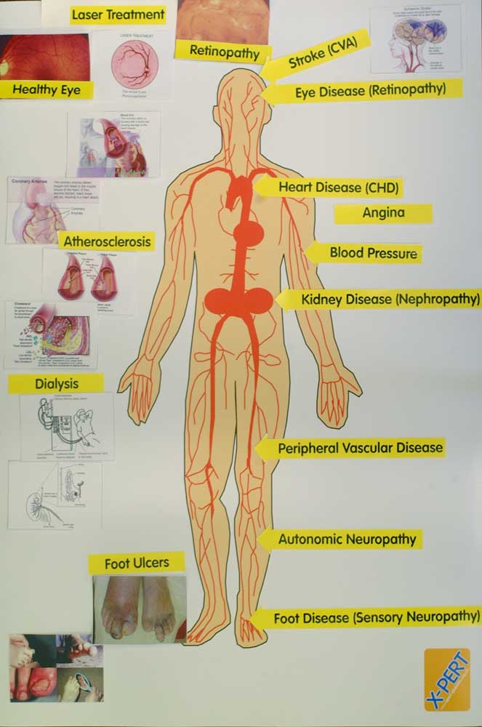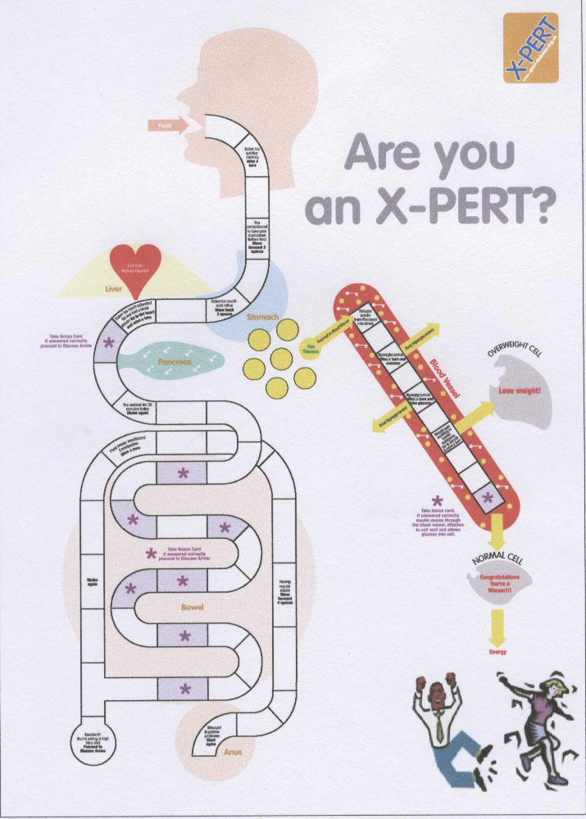

A STRUCTURED PATIENT EDUCATION PROGRAMME FOR

PEOPLE WITH TYPE 2 DIABETES

Do you want to increase your skills, knowledge and confidence in managing your diabetes?
The local X-PERT programme is a six-week group diabetes education programme. You will learn all about the up-to-date treatments and management of diabetes and will have the opportunity to explore and address problems/issues that you may have with your diabetes.

The programme has been shown to improve diabetes control, reduce diabetes tablets/insulin, increase self-management skills, improve lifestyle and quality of life.
Comments from patients:
‘This is the first time in 10 years of being a diabetic that anybody has told me these things’

‘Very glad to be offered the course, much appreciated (Thank you NHS!). Feel much encouraged in dealing with myself and more understanding with latest knowledge’

‘I am more at ease with diabetes from what I have learnt and able to control it better’

‘I was very impressed – the sessions have been delivered in a manner that had obviously gone beyond that required to make them understandable’

‘Don’t feel as frightened as I did.....feel more confident in myself…things explained so that anybody & everybody can understand’

‘This course was really helpful in helping me understand diabetes as all demonstrations were in laymen’s language - programme should have been implemented years ago’

You are invited to attend the X-PERT programme at Hackney Diabetes Centre It is important to attend all the sessions. If this is not possible, please attend all those you can. If you wish you may bring along a family member or friend.
Session 1 – 2nd October 2006
Session 2 – 9th October 2006
Session 3 – 16th October 2006
Session 4 – 23rd October 2006
Session 5 – 30th October 2006
Session 6 – 6th November 2006

All the sessions will last for 2½ hours starting at …10am……. and finishing at ……12.30pm….………
If you would like to attend please return the reply slip below to: Ann Chambers, Hackney Diabetes Centre,
Homerton Hospital, Homerton Row, London E9 6SR

………………………………………………………………………………………………………………
F.A.O… Ann Chambers..…I have diabetes and would like to attend the X-PERT Programme starting on 2nd October 2006
Name…………………………………………………………………..DOB …………………………………….
Address……………..……………………………………………………………………………………………...
Tel:………………..……...……Name of friend/family member (optional):……………………………….…..

